Micro-loan helps Mafraq woman challenge stereotypes, build ‘something that lasts’
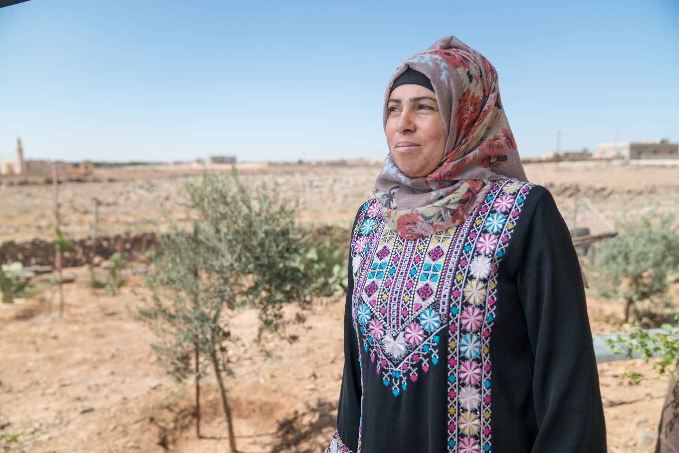
Khuloud is a farmer and a volunteer at a community-based organization in a rural area in the Governorate of Mafraq. A year ago, Khuloud received a micro-loan which she used to start her own business. She bought grapevines and soon she was able to start selling the products at the local farmers’ market.
Khuloud was inspired to start her business by another woman in her community who went through the same path. "It was the first time I ever heard of a woman in my area receiving support to start a business. And I thought that, if she can do it, maybe I could do it too." Khuloud recalls. Once the investment began to generate dividends, Khuloud bought chickens to expand her business and to differentiate her family’s source of income.
Mother of four, Khuloud's first supporters are her husband and children. "At the beginning I had my work criticized. People in my neighborhood would tell me that it's not acceptable for a woman to work at the farmers’ market, because most of workers in the market are men and I would have been absent from the house during the day due to long commuting hours to reach the place”.
At the beginning, Kholoud promoted the business in her community, starting from her children’s teachers. Initially through word of mouth, she managed to gradually have more costumers and systematize her marketing in a larger scale. “As time went by, these people got used to the idea and stopped criticizing me, and I believe that this happened because I proved myself. I didn't step down or give up. What truly matter is to have a clear vision and not feel vulnerable, while gather the support and the motivation needed from your family and beloved ones" Khuloud says.
Building on her personal experience, Khuloud is now convinced that having a solid business plan is the key to success. "Few women seem to know how to structure business plans in my area to make the best out of their ideas. I think this is why most of them fail or don't even know how to begin in the first place."
With more income available, Khuloud is now encouraging her elder children, a boy aged 16 and a girl aged 13, to pursue higher education, with the hope that one day they will have the chance to start their own business.
Kholoud has always strived to work and she is passionate to continue scaling up her initiative. "It makes me feel strong. It changed me as a person as no other experience in my life did. Having my own business taught me dedication and patience. After all the hard work, I treasure what I learn to build something that lasts."
This project was generously funded by the European Union under Regional Programme for the Economic and Political Empowerment of Women in the Southern Mediterranean Region (“Spring Forward for Women”). Implemented by UN Women, the primary focus of the project was to encourage the effective participation of marginalized women in economic and public life by addressing the barriers that have impeded their engagement in these areas.

